Assignment: Measurement of Central Tendency, Dispersion, Correlation and Regression
Using the Built-in CO2 Dataset in R
Student Name | Muhammad Hammad Shakeel
Roll Number | 28
Course / Section | BSAI, 4th (B)
Submitted To | Dr. Danish Wasim
Deadline | 08 May, 2026
Software Used | RStudio and R programming language

Introduction
This assignment presents statistical results generated from the built-in CO2 dataset in R. The variable conc is used as x and represents CO2 concentration, while uptake is used as y and represents CO2 uptake by plants. The purpose of this work is to calculate statistical measures, interpret the output, and understand the relationship between CO2 concentration and uptake.

Objective of Analysis
The objective of this analysis is to study and apply different statistical techniques using the CO2 dataset. The analysis focuses on calculating and interpreting measures of central tendency, measures of dispersion, correlation, and simple linear regression.
- To calculate arithmetic mean, geometric mean, harmonic mean, median, and mode.
- To determine quartiles, deciles, and percentiles.
- To measure variability using range, interquartile range, mean deviation, variance, standard deviation, and coefficient of variation.
- To examine the relationship between CO2 concentration and uptake using correlation analysis.
- To develop and interpret a simple linear regression model for predicting uptake from concentration.

1.2 Statistical Techniques Used
- Measures of Central Tendency: arithmetic mean, geometric mean, harmonic mean, median, and mode.
- Measures of Position: quartiles, deciles, and percentiles.
- Measures of Dispersion: range, coefficient of range, interquartile range, quartile deviation, coefficient of interquartile range, mean deviation, variance, standard deviation, and coefficient of variation.
- Correlation Analysis: Pearson correlation coefficient.
- Regression Analysis: simple linear regression model and interpretation of intercept, slope, R-squared, and p-value.
- Graphical Technique: scatter plot between CO2 concentration and uptake.

2. Measurement of Central Tendency
Table 1: Central Tendency and Positional Measures
Measure | Result | Interpretation
Arithmetic Mean (AM) | 435.0000 | The average CO2 concentration is 435 units.
Geometric Mean (GM) | 336.7378 | The geometric average is lower than the arithmetic mean, showing the influence of larger concentration values.
Harmonic Mean (HM) | 253.8142 | The harmonic mean gives more weight to lower values and is therefore the smallest average.
Median | 350.0000 | Half of the concentration values are below or equal to 350 and half are above or equal to 350.
Mode of x1 | 10 | In the separate vector x1, the value 10 appears most frequently.
Q1 | 175.0000 | 25% of concentration values are less than or equal to 175.
Q2 | 350.0000 | The second quartile is the median.
Q3 | 675.0000 | 75% of concentration values are less than or equal to 675.
Q4 | 1000.0000 | The maximum concentration value is 1000.
D7 | 500.0000 | 70% of concentration values are less than or equal to 500.
P16 | 175.0000 | 16% of concentration values are less than or equal to 175.

The arithmetic mean of concentration is 435, which means that the average CO2 concentration in the dataset is 435 units. The geometric mean is 336.7378 and the harmonic mean is 253.8142. Both of these are lower than the arithmetic mean because the concentration data contain larger values that increase the arithmetic mean.
The median is 350. This shows that the middle value of the concentration variable is 350. Since the mean is greater than the median, the data are slightly influenced by higher concentration values. The quartile results show that the middle 50% of the values lie between 175 and 675. The seventh decile is 500, which means that 70% of observations are less than or equal to 500. The 16th percentile is 175, which means that 16% of observations are less than or equal to 175.
Overall, the measures of central tendency show that the concentration values are spread from low to high levels, with the main central value lying between 350 and 435.

3. Measurement of Dispersion
Table 2: Measures of Dispersion
Measure | Result | Interpretation
Range | 905.0000 | The difference between maximum and minimum concentration values is high.
Coefficient of Range | 0.8265 | The relative difference between maximum and minimum values is large.
Interquartile Range (IQR) | 500.0000 | The middle 50% of concentration values are spread across 500 units.
Quartile Deviation (QD) | 250.0000 | Half of the IQR, showing spread around the median.
Coefficient of IQR | 0.5882 | The middle portion of the data has considerable variation.
Mean Deviation about Mean | 248.5714 | On average, observations deviate from the mean by about 248.57 units.
Coefficient of MD about Mean | 0.5714 | Mean deviation is about 57.14% of the arithmetic mean.
Mean Deviation about Median | 236.4286 | On average, observations deviate from the median by about 236.43 units.
Coefficient of MD about Median | 0.6755 | Deviation about the median is about 67.55% of the median.
Variance | 87571.0800 | A large variance shows wide spread around the mean.
Standard Deviation | 295.9241 | Concentration values differ from the mean by about 295.92 units on average.
Coefficient of Variation | 68.0285% | The concentration variable has high variation relative to its mean.
SD of Uptake | 10.8144 | Uptake values differ from their mean by about 10.81 units.
CV of Uptake | 39.7397% | Uptake varies less than concentration in relative terms.

The range of concentration is 905, calculated from the minimum value 95 and maximum value 1000. This indicates a wide distance between the smallest and largest concentration values. The coefficient of range is 0.8265, which also confirms high relative spread.
The interquartile range is 500 and the quartile deviation is 250. These values show that the middle 50% of the concentration data are widely spread around the median. The mean deviation about the mean is 248.5714, and the mean deviation about the median is 236.4286. These results show that the values are not concentrated very closely around the central value.
The variance is 87571.08 and the standard deviation is 295.9241, which are both large because the concentration values range from 95 to 1000. The coefficient of variation is 68.0285%, indicating a high level of variability in concentration. For uptake, the standard deviation is 10.8144 and the coefficient of variation is 39.7397%, which means uptake is variable but less variable than concentration.

4. Correlation and Regression
The scatter plot below shows the relationship between CO2 concentration and CO2 uptake. Each point represents one observation from the CO2 dataset.
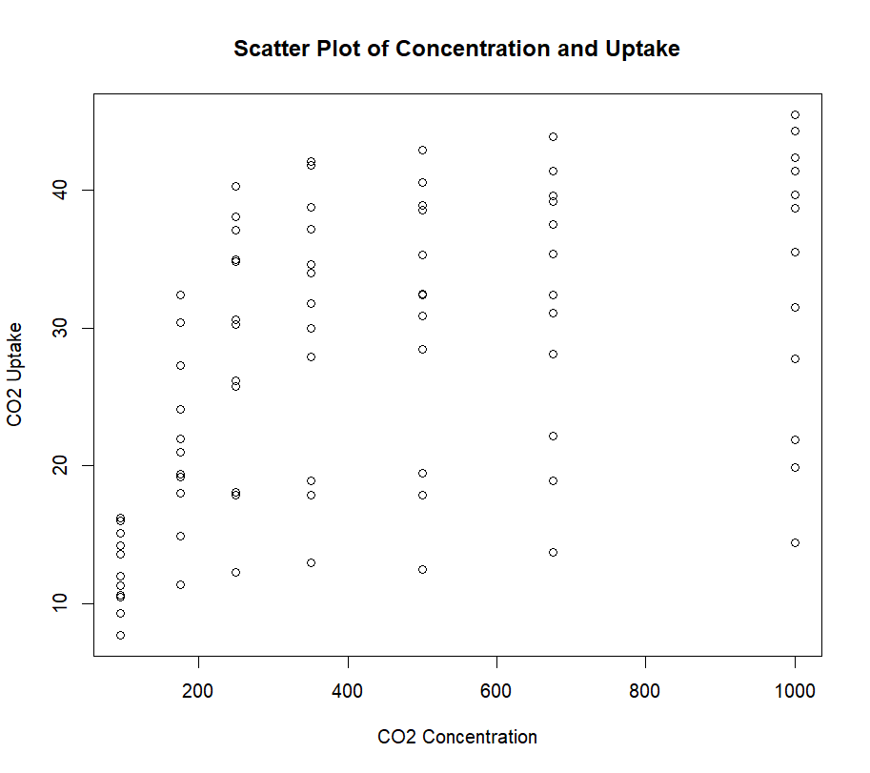
Figure 1: Scatter Plot of CO2 Concentration and Uptake
Table 3: Correlation and Regression Results
Result | Value | Interpretation
Correlation coefficient | 0.4851774 | Moderate positive relationship between concentration and uptake.
Regression equation | uptake = 19.50029 + 0.01773059(concentration) | Predicted uptake increases as concentration increases.
Intercept | 19.50029 | Predicted uptake when concentration is zero.
Slope | 0.01773059 | For every one-unit increase in concentration, predicted uptake increases by about 0.0177 units.
p-value for slope | 2.91e-06 | The slope is statistically significant.
Multiple R-squared | 0.2354 | About 23.54% of variation in uptake is explained by concentration.
Adjusted R-squared | 0.2261 | Adjusted model fit is about 22.61%.
Residual standard error | 9.514 | Average size of residual errors is about 9.514 units.

The scatter plot shows an upward trend. This means that as CO2 concentration increases, CO2 uptake generally increases. However, the points are not arranged in a perfectly straight line. There is visible spread in uptake values at the same concentration levels, which shows that other factors such as plant type and treatment may also affect uptake.
The correlation coefficient is 0.4851774. This indicates a moderate positive relationship between concentration and uptake. Since the value is positive, both variables move in the same direction: when concentration increases, uptake tends to increase. Since the value is not close to 1, the relationship is not very strong.
The simple linear regression equation is: uptake = 19.50029 + 0.01773059(concentration). In this equation, uptake is the dependent variable and concentration is the independent variable. The intercept is 19.50029, meaning that if concentration were zero, the predicted uptake would be 19.50029 units. Although zero concentration is not observed in the dataset, the intercept is needed to form the regression equation.
The slope is 0.01773059. This means that for every one-unit increase in CO2 concentration, the predicted uptake increases by approximately 0.0177 units. The p-value for the slope is 2.91e-06, which is very small, so the effect of concentration on uptake is statistically significant. The R-squared value is 0.2354, meaning that concentration explains about 23.54% of the variation in uptake. The remaining variation may be due to other variables not included in this simple model.

5. Conclusion
The analysis shows that CO2 concentration has a positive effect on plant uptake. The scatter plot and correlation coefficient both show a moderate positive relationship between concentration and uptake. The regression slope is also positive, which confirms that higher CO2 concentration is associated with higher predicted uptake.
The concentration variable has high variability, as shown by the large range, standard deviation, and coefficient of variation. Uptake also varies, but its relative variation is lower than concentration. The regression model is statistically significant, but the R-squared value shows that concentration alone explains only part of the variation in uptake. Therefore, other factors such as plant type and treatment may also play an important role.
Overall, the results conclude that concentration affects uptake positively, but it is not the only factor responsible for changes in uptake. The analysis successfully applies measures of central tendency, dispersion, correlation, regression, and graphical interpretation using R.

Appendix A: R Code Used to Generate the Results
The following R code was used to generate the statistical results and scatter plot used in this assignment.
rm(list=ls())

data(CO2)
View(CO2)

x = CO2$conc
x

y = CO2$uptake
y

n = length(x)
n

################## Measurement of Central Tendency ##################

AM = mean(x)
AM

GM = (prod(x))^(1/n)
GM

HM = n / sum(1/x)
HM

MED = median(x)
MED

x1 = c(2,4,5,3,8,7,2,5,7,10,2,10,15,10,10)
MOD = names(sort(table(x1), decreasing = TRUE))[1]
MOD
Q1 = quantile(x, 0.25)
Q2 = quantile(x, 0.50)
Q3 = quantile(x, 0.75)
Q4 = quantile(x, 1)
Q1
Q2
Q3
Q4

D7 = quantile(x, 0.70)
D7

P16 = quantile(x, 0.16)
P16

summary(x)

################## Measurement of Dispersion ##################

Range = max(x) - min(x)
Range

CRange = (max(x) - min(x)) / (max(x) + min(x))
CRange

IQR = Q3 - Q1
IQR

QD = IQR / 2
QD

CIQR = (Q3 - Q1) / (Q3 + Q1)
CIQR

################## Mean Deviation ##################

MD = sum(abs(x - AM)) / n
MD

CMD = MD / AM
CMD

################## Mean Deviation about Median ##################

MD1 = sum(abs(x - MED)) / n
MD1

CMD1 = MD1 / MED
CMD1

################## Variance, Standard Deviation and Coefficient of Variation ##################

V = var(x)
V

SD = sqrt(V)
SD

CV = SD / AM * 100
CV

SD1 = sqrt(var(y))
SD1

CV1 = SD1 / mean(y) * 100
CV1

################## Simple Correlation and Regression ##################

plot(x, y,
main = "Scatter Plot of Concentration and Uptake",
xlab = "CO2 Concentration",
ylab = "CO2 Uptake")

cor(x, y)

model = lm(y ~ x)
model

summary(model)

a1 = coefficients(model)[1]
a1

b1 = coefficients(model)[2]
b1

y.hat = a1 + b1 * x
y.hat

Error = sum(y - y.hat)
Error

